E19-868M30S User Manual

SX1276 868MHz 1W SMD Wireless Module

Contents
Disclaimer 2
1. Overview 3
1.1 Brief introduction 3
1.2 Features 3
1.3 Application 3
2 Specification and parameter 4
2.1 Limit parameter 4
2.2 Operating parameter 4
3.Size and pin definition 5
4. Basic operation 6
4.1 Hardware design 6
4.2 Software editing 7
5.Basic application 8
5.1 Basic circuit diagram 8
6.FAQ 8
6.1 Communication range is too short 8
6.2 Module is easy to damage 9
6.3 BER(Bit Error Rate) is high 9
7.Production guidance 9
7.1 Reflow soldering temperature 9
7.2 Reflow soldering curve 10
8 E19 Series 10
9. Antenna guidance 11
9.1 Antenna recommendation 11
9.2 Antenna selection 11
10.Package for batch order 12
Revision history 12
About us 12

Disclaimer
EBYTE reserves all rights to this document and the information contained herein. Products, names, logos and designs described herein may in whole or in part be subject to intellectual property rights. Reproduction, use, modification or disclosure to third parties of this document or any part thereof without the express permission of EBYTE is strictly prohibited.
The information contained herein is provided “as is” and EBYTE assumes no liability for the use of the information. No warranty, either express or implied, is given, including but not limited, with respect to the accuracy, correctness, reliability and fitness for a particular purpose of the information. This document may be revised by EBYTE at any time. For most recent documents, visit www.ebyte.com.

Overview

1.1 Brief introduction
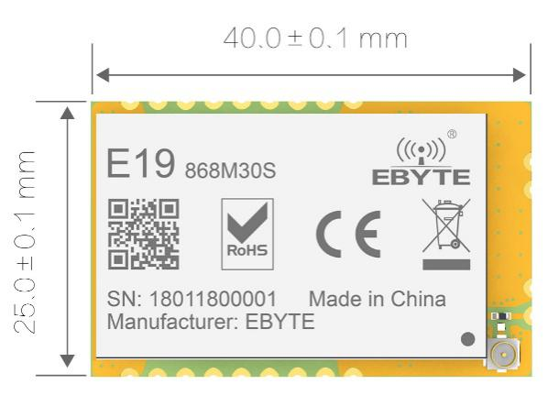
E19-868M30S is a small-sized 868MHz LoRaTM SMD wireless module, based on the original imported RF chip SX1276 from SEMTECH.
Due to the use of the imported SX1276 as the core of the module, with its stable and reliable characteristics, it is favored by the majority of users. Compared with the FSK、GFSK prod6ucts, it has made great progress in receiving current, receiving sensitivity, transmitting power, receiving rate range and anti-interference ability. The module is aimed at smart home, wireless meter reading, scientific research and medical, and medium and long distance wireless communication equipment. Since RF performance and component selection are in accordance with industrial standards, and the product has obtained FCC, CE, RoHS and other international authoritative certification reports, users do not need to worry about its performance. High precision 32MHz crystal is used.

Since the module is a pure RF transceiver module, you need to use the MCU driver or a dedicated SPI debug tool.

1.2 Features
- Communication distance tested is up to 10km；
- Maximum transmission power of 1W, software multi-level adjustable；
- Support the global license-free ISM 868MHz band；
- Support air date rate of 0.018kbps~37.5kbp in LoRaTM；
- The maximum data transmission rate 300kpbs in FSK mode；
- Support multiple modulation methods, LoRaTM/FSK/GFSK/MSK/GMSK/OOK；
- Large capacity FIFO, supports 256Byte data buffer；
- Support 2.5V~5.5V power supply, power supply over 5.0V can guarantee the best performance；
- Industrial grade standard design, support -40 ~ 85 °C for working over a long time；
- Stamp hole, good for secondary development and integration.

1.3 Application
- Home security alarm and remote keyless entry；
- Smart home and industrial sensors；
- Wireless alarm security system；
- Building automation solutions；
- Wireless industrial-grade remote control；
- Health care products；
- Advanced Meter Reading Architecture(AMI)；
- Automotive industry applications.

2 Specification and parameter

2.1 Limit parameter
Main parameter | Performance |  | Remark
 | Min. | Max.
Power supply（V） | 0 | 5.5 | Voltage over 5.5V will cause permanent damage to module
Blocking power（dBm） | - | 10 | Chances of burn is slim when modules are used in short distance
Operating temperature（℃） | -40 | 85 | /

2.2 Operating parameter
Main parameter |  | Performance |  |  | Remark
 |  | Min. | Typ. | Max.
Operating voltage（V） |  | 3.3 | 5.0 | 5.5 | ≥5.0 V ensures output power
Communication level（V） |  |  | 3.3 |  | For 5V TTL, it may be at risk of burning down
Operating temperature（℃） |  | -40 | - | 85 | Industrial design
Operating frequency（MHz） |  | 862 | 868 | 893 | Support ISM band
Power consumption | TX current（mA） |  | 620 |  | Instant power consumption
 | RX current（mA） |  | 23
 | Sleep current （μA） |  | 3.0 |  | Software is shut down
Max Tx power（dBm） |  | 28.5 | 30 | 30
Receiving sensitivity（dBm） |  | -145 | -147 | -148 | Sensitivity test conditions：  air data rate: 0.3 kbps, Coding rate 4/5, Spread Spectrum Factor 12.
Air data rate（bps） |  | 1.2 | - | 300 | Kbps | FSK
 |  | 0.018 | - | 37.5 | Kbps | LoraTM

Main parameter | Description | Remark
Distance for reference | 10000m | Test condition：clear and open area, antenna gain: 5dBi，antenna height: 2.5m，air data rate: 0.3kbps
FIFO | 256Byte | Max length transmitted each time
Crystal frequency | 32MHz
Modulation | LoRaTM (recommended) | FSK/GFSK/MSK/GMSK/OOK
Package | SMD
Connector | 1.27mm
Communication interface | SPI | 0-10Mbps
Size | 25.0*40.0 mm
Antenna | Stamp hole | 50 ohm impedance

3.Size and pin definition
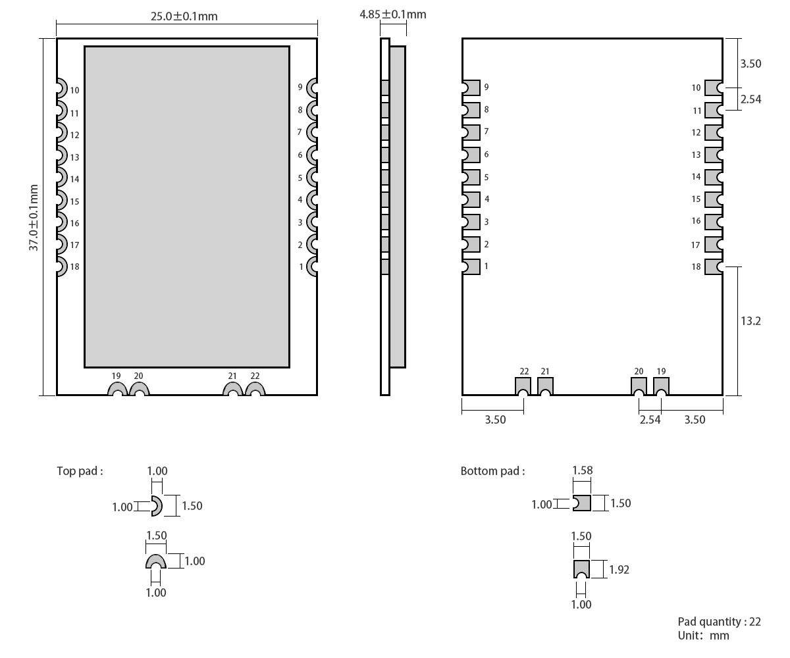
Pin No | Pin item | Pin direction | Pin application
1 | GND | - | Ground electrode, connected to the power reference ground
2 | DIO5 | Input/Output | Configurable IO port（Please find more on SX1276 datasheet）
3 | DIO4 | Input/Output | Configurable IO port（Please find more on SX1276 datasheet）
4 | DIO3 | Input/Output | Configurable IO port（Please find more on SX1276 datasheet）
5 | DIO2 | Input/Output | Configurable IO port（Please find more on SX1276 datasheet）
6 | DIO1 | Input/Output | Configurable IO port（Please find more on SX1276 datasheet）
7 | DIO0 | Input/Output | Configurable IO port（Please find more on SX1276 datasheet）
8 | RST | Input | Reset
9 | GND | - | Ground electrode, connected to the power reference ground.
10 | GND | - | Ground electrode, connected to the power reference ground.
11 | VCC | - | Power supply: 4.75~5.5V (Ceramic filter capacitoris advised to add)
12 | SCK | Input | SPI clock
13 | MISO | Output | SPI clock
14 | MOSI | Input | SPI clock
15 | NSS | Input | Chip select
16 | TXEN | Input | Radio frequency switch control, make sure the TXEN pinis in high level, RXEN pin is in low level when transmitting.
17 | RXEN | Input | Radio frequency switch control, make sure the TXEN pinis in high level, RXEN pin is in low level when transmitting
18 | GND | - | Ground electrode, connected to the power reference ground
19 | ANT | - | Antenna
20 | GND | - | Ground electrode, connected to the power reference ground
21 | GND | - | Ground electrode, connected to the power reference ground
22 | GND | - | Ground electrode, connected to the power reference ground

Basic operation

Hardware design
- It is recommended to use a DC stabilized power supply. The power supply ripple factor is as small as possible, and the module needs to be reliably grounded.；
- Please pay attention to the correct connection of the positive and negative poles of the power supply. Reverse connection may cause permanent damage to the module；
- Please check the power supply to ensure it is within the recommended voltage otherwise when it exceeds the maximum value the module will be permanently damaged；
- Please check the stability of the power supply, the voltage can not be fluctuated frequently；
- When designing the power supply circuit for the module, it is often recommended to reserve more than 30% of the margin, so the whole machine is beneficial for long-term stable operation.；
- The module should be as far away as possible from the power supply, transformers, high-frequency wiring and other parts with large electromagnetic interference.；
- High-frequency digital routing, high-frequency analog routing, and power routing must be avoided under the module. If it is necessary to pass through the module, assume that the module is soldered to the Top Layer, and the copper is spread on the Top Layer of the module contact part(well grounded), it must be close to the digital part of the module and routed in the Bottom Layer；
- Assuming the module is soldered or placed over the Top Layer, it is wrong to randomly route over the Bottom Layer or other layers, which will affect the module's spurs and receiving sensitivity to varying degrees；
- It is assumed that there are devices with large electromagnetic interference around the module that will greatly affect the performance. It is recommended to keep them away from the module according to the strength of the interference. If necessary, appropriate isolation and shielding can be done；
- Assume that there are traces with large electromagnetic interference (high-frequency digital, high-frequency analog, power traces) around the module that will greatly affect the performance of the module. It is recommended to stay away from the module according to the strength of the interference.If necessary, appropriate isolation and shielding can be done.
- If the communication line uses a 5V level, a 1k-5.1k resistor must be connected in series (not recommended, there is still a risk of damage)；
- Try to stay away from some physical layers such as TTL protocol at 2.4GHz , for example: USB3.0；
- The mounting structure of antenna has a great influence on the performance of the module. It is necessary to ensure that the antenna is exposed, preferably vertically upward. When the module is mounted inside the case, use a good antenna extension cable to extend the antenna to the outside；
- The antenna must not be installed inside the metal case, which will cause the transmission distance to be greatly weakened.

4.2 Software editing
- SX1278/SX1276+PA+LNA，same drive way as SX1278/SX1276，user can refer to SX1278/SX1276 datasheet.
- DIO0、DIO1、DIO2、DIO3、DIO4、DIO5 are configurable I/O ports for various application，see more in SX1276 datasheet. It can be floated when not used.
- RST、TXEN、RXEN must be connected,among which RST control chip reset，TXEN, RXEN are for controlling RF switch.
- Make it ground well with large space for grounding and small power ripple. Filter capacitor is necessary and make sure it is close to pin VCC and GND.
- SPI communication rate should not be set too high, usually around 1Mbps.
- In transmitting，set TXEN as high communication level，RXEN pin is low level; In receiving, set RXEN as high communication level,TXEN is low level; Before powering off, set TXEN、RXEN as low level.
- Re-initialize register configuration when the chip is idle for higher stability.

5.Basic application

5.1 Basic circuit diagram
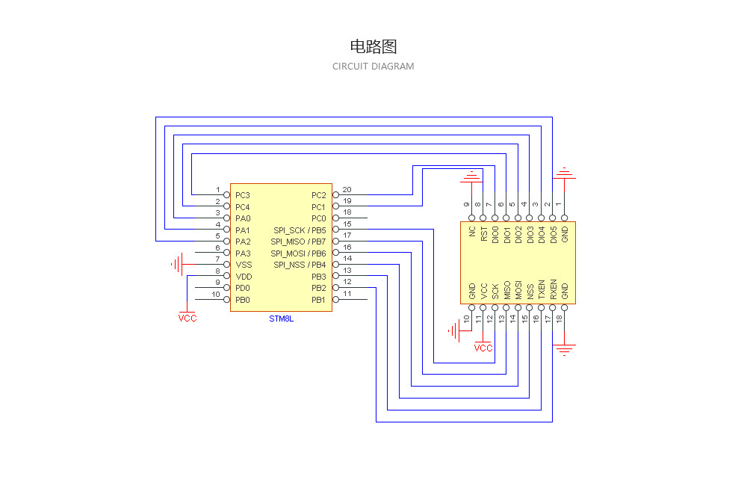

6.FAQ

6.1 Communication range is too short
- The communication distance will be affected when obstacle exists.
- Data lose rate will be affected by temperature, humidity and co-channel interference.
- The ground will absorb and reflect wireless radio wave, so the performance will be poor when testing near ground.
- Sea water has great ability in absorbing wireless radio wave, so performance will be poor when testing near the sea.
- The signal will be affected when the antenna is near metal object or put in a metal case.
- Power register was set incorrectly, air data rate is set as too high (the higher the air data rate, the shorter the distance).
- The power supply low voltage under room temperature is lower than 2.5V, the lower the voltage, the lower the transmitting power.
- Due to antenna quality or poor matching between antenna and module.

6.2 Module is easy to damage
- Please check the power supply source, ensure it is 2.0V~3.6V, voltage higher than 3.6V will damage the module.
- Please check the stability of power source, the voltage cannot fluctuate too much.
- Please make sure antistatic measure are taken when installing and using, high frequency devices have electrostatic susceptibility.
- Please ensure the humidity is within limited range, some parts are sensitive to humidity.
- Please avoid using modules under too high or too low temperature.

6.3 BER(Bit Error Rate) is high
- There are co-channel signal interference nearby, please be away from interference sources or modify frequency and channel to avoid interference;
- Poor power supply may cause messy code. Make sure that the power supply is reliable.
- The extension line and feeder quality are poor or too long, so the bit error rate is high;

7.Production guidance

7.1 Reflow soldering temperature

Profile Feature | Curve characteristics | Sn-Pb Assembly | Pb-Free Assembly
Solder Paste | Solder paste | Sn63/Pb37 | Sn96.5/Ag3/Cu0.5
Preheat Temperature min （Tsmin） | Min preheating temp. | 100℃ | 150℃
Preheat temperature max (Tsmax) | Mx preheating temp. | 150℃ | 200℃
Preheat Time (Tsmin to Tsmax)(ts) | Preheating time | 60-120 sec | 60-120 sec
Average ramp-up rate(Tsmax to Tp) | Average ramp-up rate | 3℃/second max | 3℃/second max
Liquidous Temperature (TL) | Liquid phase temp. | 183℃ | 217℃
Time（tL）Maintained Above（TL） | Time below liquid phase line | 60-90 sec | 30-90 sec
Peak temperature（Tp） | Peak temp. | 220-235℃ | 230-250℃
Aveage ramp-down rate（Tp to Tsmax） | Aveage ramp-down rate | 6℃/second max | 6℃/second max
Time 25℃ to peak temperature | Time to peak temperature for 25℃ | max 6 minutes | max 8 minutes

7.2 Reflow soldering curve
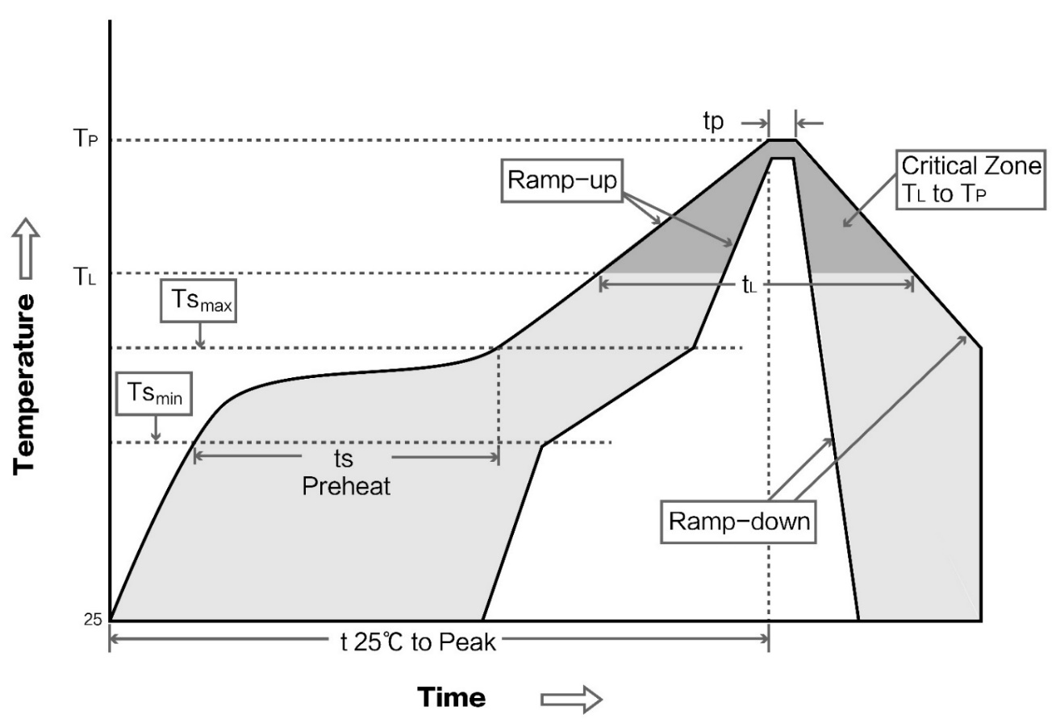

8 E19 Series
Model No. | IC | Frequency(Hz) | Tx power (dBm) | Test distance km | Package | Antenna | Model No.
E19-433M20S2 | SX1278 | 433M | 20 | 5 | SMD | 15 * 15 | Stamp hole
E19-915M30S | SX1276 | 915M | 30 | 10 | SMD | 25 * 40 | Stamp hole /IPEX
E19-868M30S | SX1276 | 868M | 30 | 10 | SMD | 25 * 40 | Stamp hole /IPEX
E19-868M20S | SX1276 | 868M | 20 | 5 | SMD | 17.6*25.2 | Stamp hole
E19-433M30S | SX1278 | 433M | 30 | 10 | SMD | 25*37 | Stamp hole
E19-915M20S | SX1276 | 915M | 20 | 5 | SMD | 17.6*25.2 | Stamp hole
E19-433M20SC | SX1278 | 433M | 20 | 5 | SMD | 17.6*25.2 | Stamp hole

Antenna guidance

9.1 Antenna recommendation
The antenna is an important role in the communication process. A good antenna can largely improve the communication system. Therefore, we recommend some antennas for wireless modules with excellent performance and reasonable price.
Model No. | Type | Frequency Hz | Interface | Gain  dBi | Height | Cable | Function feature
TX868-XP-100 | Sucker | 868M | SMA-J | 3.5 | 29cm | 100cm | Sucker antenna, High gain
TX868-JK-20 | Rubber | 868M | SMA-J | 3 | 200mm | - | Flexible &omnidirectional
TX868-JZ-5 | Rubber | 868M | SMA-J | 2 | 50mm | - | Short straight &omnidirectional

9.2 Antenna selection
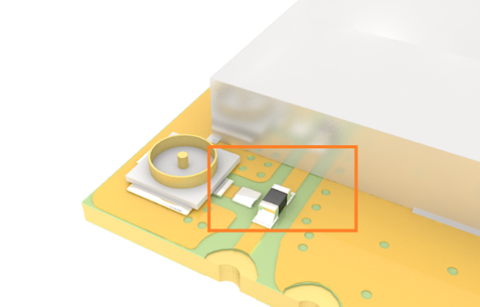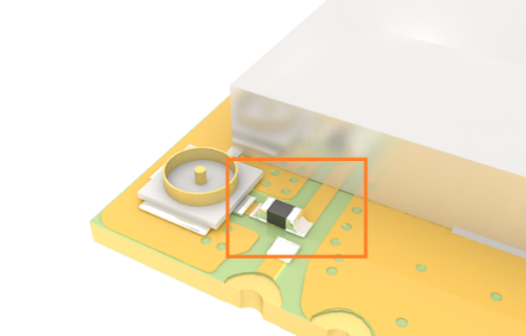
Stamp hole（default） IPEX

10.Package for batch order
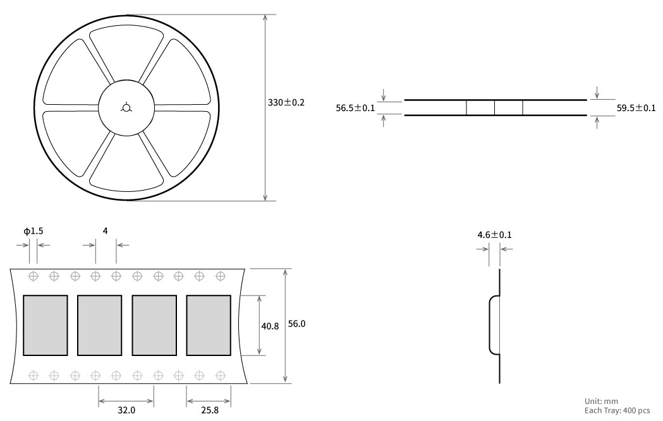

Revision history
Version | Date | Description | Issued by
1.00 | 2017/10/16 | Initial version | huaa
1.10 | 2018/5/23 | Content updated | huaa
1.20 | 2018/9/21 | Model No. split | Huaa

About us
Website: www.ebyte.com Sales: info@cdebyte.com Support: support@cdebyte.com
Tel: +86-28-61399028 Ext. 812 Fax: +86-28-64146160
Address: Innovation Center B333~D347, 4# XI-XIN road,High-tech district (west), Chengdu, Sichuan, China

